**Documentation on AUDITING:**

Basically the scope of the project is to build a software for the creation of AUDIT MODULE, which enables companies to manage their entire audit process.

**Technologies Used**: MVC 5, .net Framework 4.0.

The workflow for the creation of audit module:

The AUDIT MODULE will be consisting of the below mentioned configurable pages in sequence.

**Sequential Pages:**

* **Login Page**

Basically three rolls comes into picture.

1. Admin
2. SMEs
3. Auditor ( who verifies all the acts and laws)

* **Organization**

Organization comes under the parent category, below which different companies will be listed in particular locations.

The attributes of organization are displayed in the below screenshot;

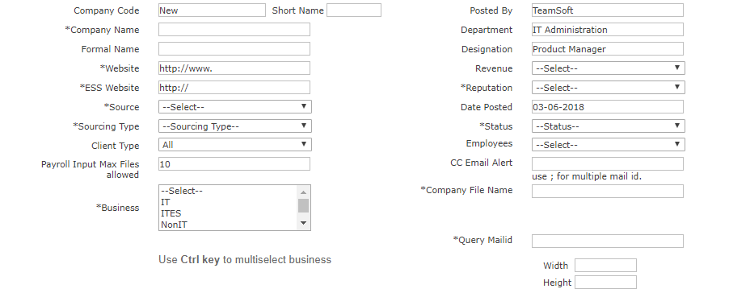

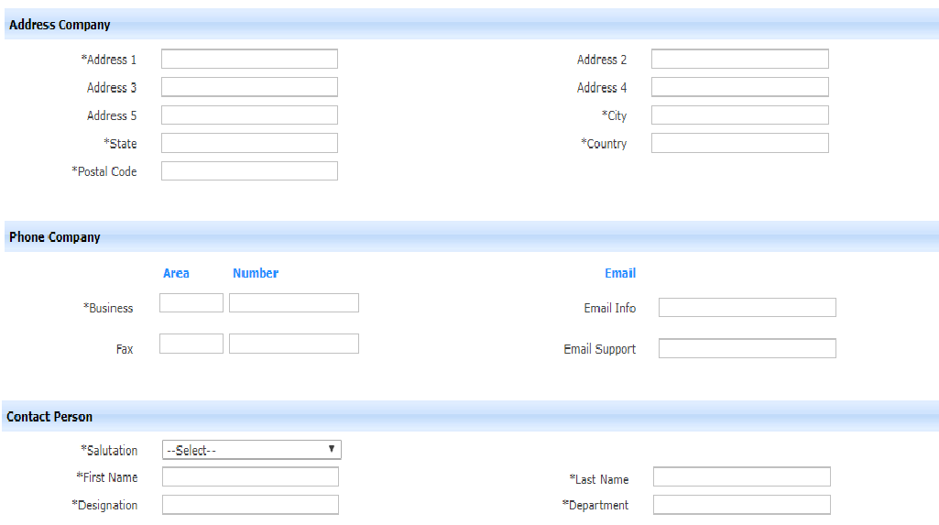

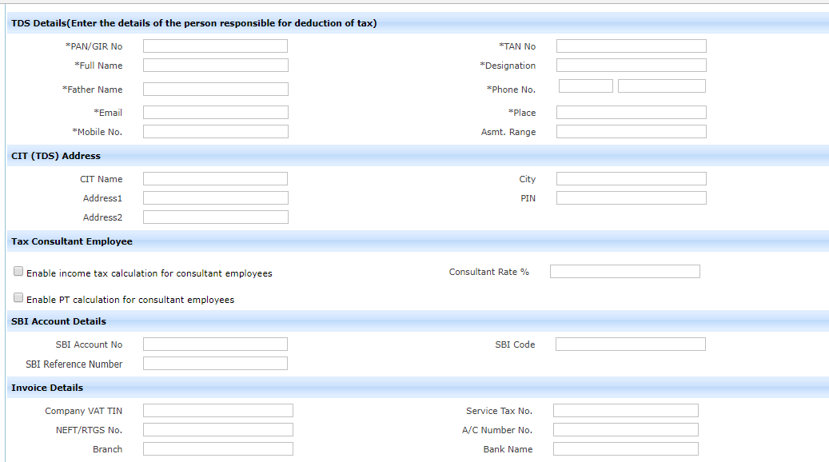

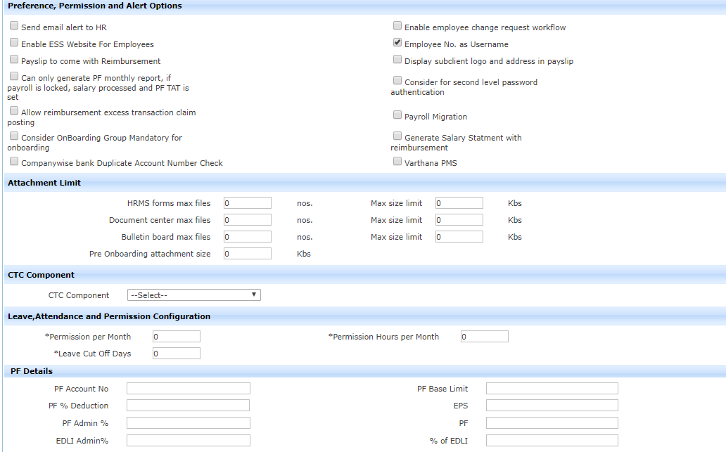

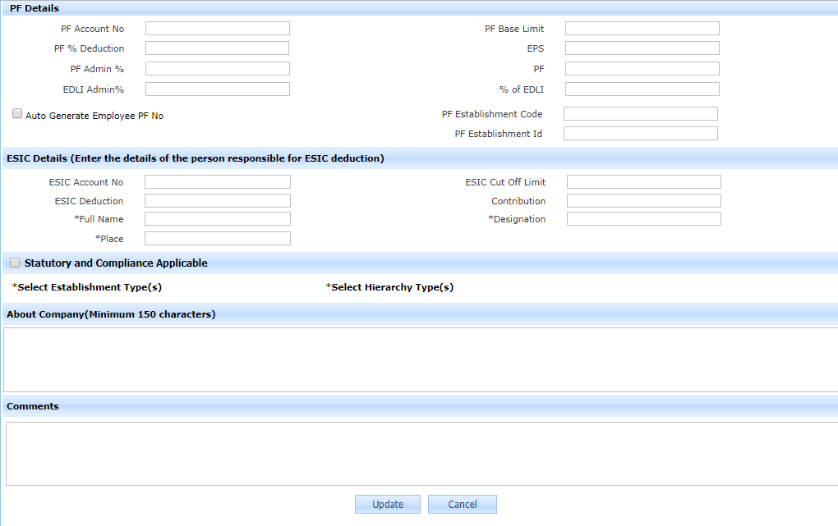

* **Company**

Many companies comes under Organization. The attributes of companies are displayed in the below screenshot.

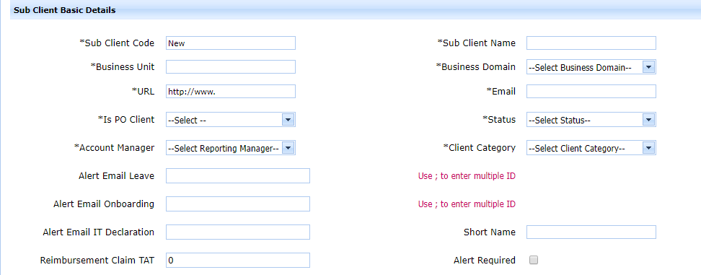

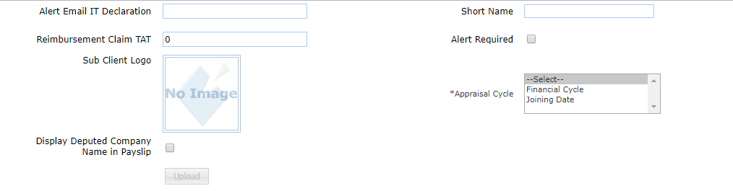

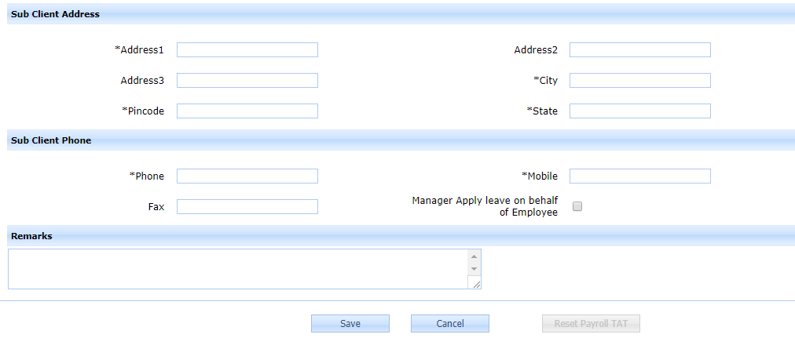

* **Branch**

Branch here is basically referred to location, where the particular company is located.

* **Organization Compliance and Contractors Compliance**

A company or an organization, situated at particular location will follow some set of rules or requests.

**Organization Compliance:**

1. Law 1
2. Law 2
3. Law 3

**Contractors Compliance:**

1. Law 1
2. Law 2
3. Law **3**

**Audit Report Input format**

|  |  |  |  |  |  |  |
| --- | --- | --- | --- | --- | --- | --- |
| S. No. | Act Details | Description | Risk Category | Compliance | Fines and Penalty in case of non- compliance | Audit Remarks |
| 1 | Shop and Establishment | Registration | 1. High Risk 2. Low Risk 3. Moderate Risk 4. No Risk | 1. Complied 2. Partially Complied 3. Non-compliance |  |  |
| 2 |  | Validity of the Licence |  |  |  |  |
| 3 |  | Registers and Maintenance |  |  |  |  |
| 4 |  |  |  |  |  |  |

Final Audit remarks: - Final remarks on each and every Acts.

Description will be containing Main sub-headings.

From the above template, the following details will be derived:

1. Risk and compliance analysis – each Act wise
2. Overall risk and compliance analysis
3. Score card for the compliance level
4. Non-compliance and audit remarks report